Amount of Data Loaded
"Amount of data loaded" refers to the quantity of data imported from the database into Power BI for analysis and visualization. In this project, the online_education_dataset table from the online_education_db database is connected to Power BI.
The loaded dataset contains student-level information used to analyze academic performance, engagement, dropout, risk level, final results, regional patterns, and other learning-related factors. The data loaded into Power BI is checked to ensure that the required records and fields are available for creating KPIs, charts, filters, and analytical visuals.
"The project establishes a live data connection between Power BI and the online_education_db MySQL database. A total corpus of 29,741 records from the online_education_dataset table was imported.
After verifying unique instances across 26,074 distinct student IDs, the data was structured to preserve 15 key dimensional and fact-based columns.
MySQL Workbench — online_education_db and online_education_dataset

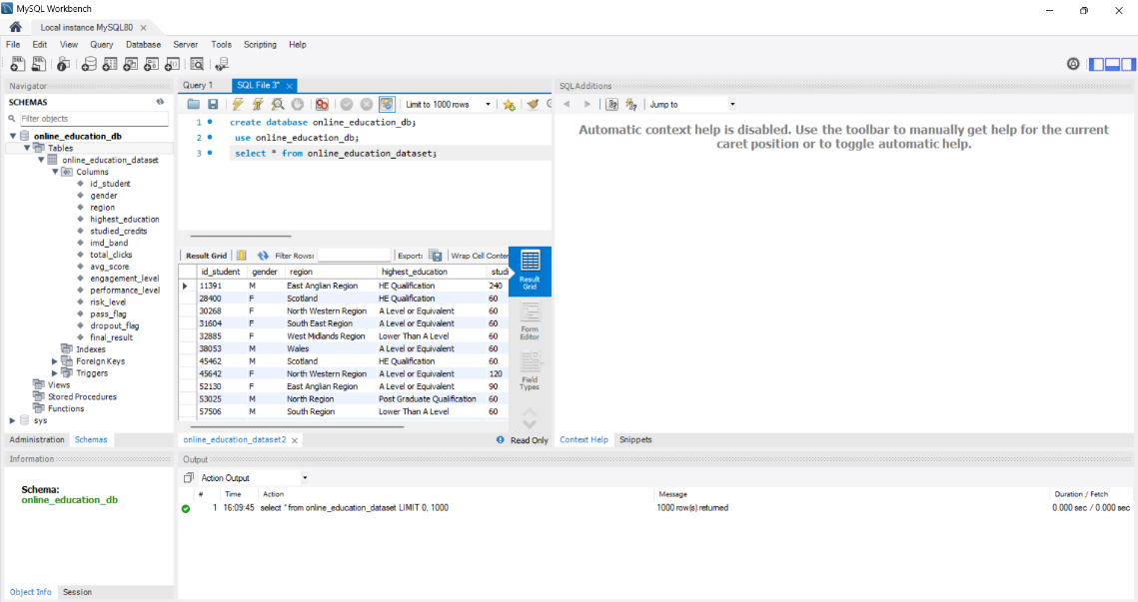
This rich dataset forms the foundation for tracking student engagement thresholds (via total clicks), measuring educational disparity metrics (via imd_band), and calculating critical outcome KPIs like attrition, failure risks, and final grade completion rates."

